6
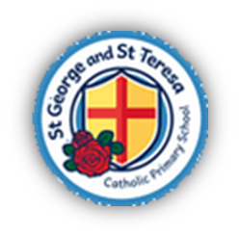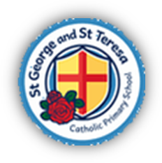St George and St Teresa Catholic Primary School
“We live it, love it and learn it”
Year Two

Curriculum Map
2026-2027

 | Autumn |  | Spring |  |  | Summer
 | Autumn 1 | Autumn 2 | Spring 1 |  | Spring 2 | Summer 1 | Summer 2
Catholic Schools' Pupil Profile | Compassionate and Loving | Faith-filled and Hopeful | Eloquent and Truthful |  | Learned and Wise | Curious and Active | Intentional and Prophetic
Catholic Social Teaching | Stewardship of God’s Creation
Catholic Social Teaching | Family and Community | Dignity of the Human Person | Rights and Responsibilities |  | Option for the Poor and Vulnerable | Dignity of Work | Solidarity and the Common Good
RE – Learning and Growing as the People of God | Branch One – Creation and Covenant | Branch Two – Prophecy and Promise | Branch Three – Galilee to Jerusalem |  | Branch Four – Garden to Desert | Branch Five – To the Ends of the Earth | Branch Six – Dialogue and Encounter
Relationships and Health Education (RHE) | Module 1, Unit 1  ‘Let the children come.’ |  |  | Module 1 unit 2 | KS1 Module 1, Unit 3 | KS1 Module 1 Unit 4  KS1, Module 2, Unit 3 | KS1, Module 3, Unit 1 and 2
English - Writing | Theme: Bravery Vs Fear  The Bear under the stairs – Helen Cooper (information leaflet) | Theme: A twist in the tale  You and ME (Narrative) | Theme: Creation & Conservation  The Journey Home – Fran Preston-Gannon (Persuasive Letters) |  | Theme: The world around us  The Great Fire  of London -  Emma Adams (Information Booklet) | Theme: Fictional Worlds & Fantasy  The Dragon Machine – Helen Ward (own version dragon stories) | Theme: Change & Relationship  Owl and the Pussycat – Edward Lear (Rhyming Poems
English - Reading | Rabbit and Bear – Julian Gough | A Book of Bears  Katie Viggers | Too small tola |  | There’s a Rang-Tan in my  Bedroom -  James Sellick | Eric - Shaun Tan | The Street beneath my feet – Charlotte Guillian
Maths | Place value  Addition and subtraction | Addition and subtraction  Shape | Money  Multiplication and Division |  | Multiplication and division  Length and height | Fractions  Time | Statistics  Position and direction
Science | Living things and their habitats | Uses of materials | Animals and survival |  | Plants and growth | Protecting the environment
Art and Design  D and T combined | Mechanisms: Making a moving monster | Craft and Design: Map it Out | Mechanisms: Fairground wheel |  | Sculpture and 3D: Clay houses | Painting and mixed media: Life in colour | Structures: Baby Bear’s chair
Computing | Online Safety What is a Computer? | Algorithms and debugging | Computing and networks 2. Word processing |  | Scratch Jr | Stop motion | International Space Station
Geography |  |  | Planet earth |  |  | Life in Kenya
History | Kings and Queens |  | Great fire of London |  |  | They made a difference
Music | Call and Response |  | Musical Storytelling |  |  | Musical Me: Pitch
Physical Education | PE  Fundamentals  Games  Multi-skills – Ball Skills | PE  Gymnastics  Games  Multi-skills – Invasion games | PE  Dance  Games  Multi-skills - Sending & receiving |  | PE  Team Building  Games  Multi-skills – Net & Wall games | PE  Athletics  Games  Multi-skills - Striking & Fielding | PE  Athletics - Sports day  Games  Target Games  Golf - Tri-Golf

