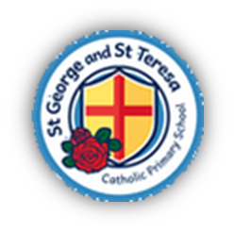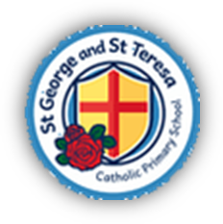St George and St Teresa Catholic Primary School
“We live it, love it and learn it”
Year Six Curriculum Map 2026-2027
 | Autumn |  | Spring |  | Summer
 | Autumn 1 | Autumn 2 | Spring 1 | Spring 2 | Summer 1 | Summer 2
Catholic Schools' Pupil Profile | Compassionate and Loving | Faith-filled and Hopeful | Eloquent and Truthful | Learned and Wise | Curious and Active | Intentional and Prophetic
Catholic Social Teaching | Stewardship of God’s Creation
Catholic Social Teaching | Family and Community | Dignity of the Human Person | Rights and Responsibilities | Option for the Poor and Vulnerable | Dignity of Work | Solidarity and the Common Good
RE – Learning and Growing as the People of God | Branch One – Creation and Covenant | Branch Two – Prophecy and Promise | Branch Three – Galilee to Jerusalem | Branch Four – Garden to Desert | Branch Five – To the Ends of the Earth | Branch Six – Dialogue and Encounter
Relationships and Health Education (RHE) and PSHE |  | UKS2 Module 1, Unit 1 and 2 | UKS2 Module 1, Unit 3 | UKS2 Module 1, Unit 4 | UKS2 Module 2, Unit 2 | UKS2 Module 3, Unit 1 and 2
English | Theme: Journeys & Migration  The Arrival Shaun Tan (Diary entry) | Theme: Evolution & Inheritance  The Last Bear – Hannah Gold  (Newspaper articles) | Theme: Protest & Activism  Leila and the Blue Fox (First person narrative) | Theme: Utopia & Dystopia  Hugo Cabret – Brian Selznick (Biography) | Theme: Fate Vs Free Will  The Promise – Nicola Davies (Narrative Poetry) | Theme: Crossing Borders  After the War – Tom Palmer  (Narrative)
Reading | Fly me home – Polly Yen | Darwin’s voyage and discovery – Jake Williams | Malala – Malala Yousafzai | Hugo Cabret – Brian Selznick | Beetle Boy – M.G. Leonard | Some Places More than Others – Renee Watson
Maths | Place Value  Addition, subtraction, multiplication and division | Fractions A  Fractions B  Measurement- converting units | Ratio  Algebra  Decimals | Fractions, decimals and percentages  Area, perimeter and volume  Statistics | Geometry – Shape  Geometry – position and direction  SATs preparation | Themed projects, consolidation and problem solving
Science | Light and Perception | Classification | Evolution and Inheritance | Electricity and Circuits | Circulation and Lifestyle
Art and Design | Photography |  | Make my voice Heard |  | Still Life  Art & Design Skills
Computing | Online Safety | Data Handling – Big Data 1 | Computing Systems and Networks - Bletchley Park Online Safety | Creating media – History of Computers | Online Safety | Programming – intro to Python
Design and Technology | Textiles: Waistcoats |  | Structure: Playgrounds |  | Digital World: Navigating the World
Geography |  | Global Challenges |  |  | Mapping the World
History | Ancient Egyptians |  | Conflict and Resolution |  |  | Making our Mark
Languages - French | French Sport and the Olympics | French Football Champions | In my French House | Planning a French Holiday | Visiting a Town in France
Music | Ukulele | Four Chord Pop: Playing in a Band | Songs That Speak: Lyrics and Messages |  | Music Technology: Film Soundtracks
Physical Education | PE  Gymnastics  Games  Netball | PE  OAA  Games  Dodgeball | PE  Dance  Games  Tag Rugby | PE  Fitness  Games  Football | PE  Games  Cricket | PE  Athletics - Sports Day  MAC Athletics  Games  Rounders

